---------------------------------------------------------------------Notes---------------------------------------------------------------------

Important points:

1.What is Hypertext?

Hypertext is a text which have hyperlinks present in them.

2.What is Hyper link?

Hyperlink are basically text which takes you to some other page or other reference material.

3. What is a Markup?

Markup is basically structure to your websites.

4. What is Language?

Language is a mode of communication.

CSS--Cascading style sheets.

5.What is CSS?

CSS beautifies the webpage to make it look good.

6.What is JavaScript?

JavaScript is a programming language (scripting language) which is used to add interactivity in your websites. It is the only programming language that is understood by the browser directly.

7.What is a programming language?

Programming language is a language in which we can write our own logics and those logics can be understood by the browser.

Browser has two types of engines:

1.Layout engine

2.Javascript engine

Difference between layout engine and JavaScript engine:

Layout engine: --

Html +CSS

JavaScript engine: --

JavaScript logics

Engine is a software which is Combination of Codes.

DNS (Domain name system): -- As humans it is difficult for us to memorise numbers so for the alternative of it, we do remember the names. Same goes with your websites. Each websites have a domain name system which is aligned with a unique Ip address, so when we called the domain name system the Corresponding IP automatically gets call.

Example: -- Instagram.com, google.com

Request Response cycle:

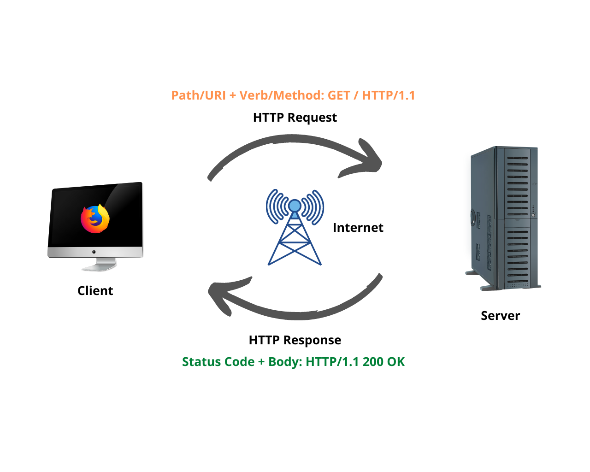

The request and response cycle involves communication between you, and by you, I mean your web browser, and a server somewhere

Note: First HTML file should always be index.html if you want your website to be produced or hosted.

(because of the predefined rules).

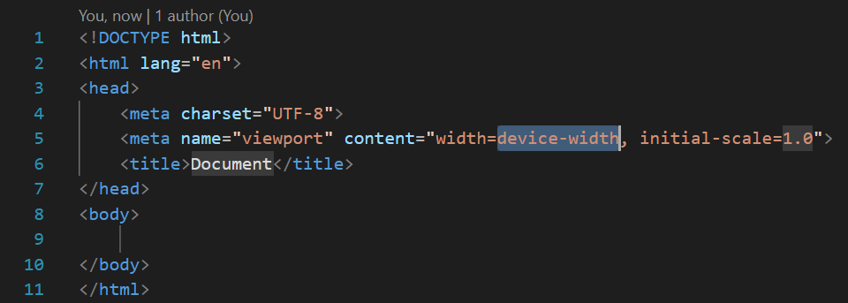

After writing html 5 we got our boilerplate code.

Boilerplate code is a predefined code that will use many times by the developer. It is like a common code that will use as a syntax for program.

Boilerplate: it is the basic level of code which defines the structure of html.

Emmet: They are prewritten Chunk of code which can be autocompleted using emmet.

Boilerplate Code:

<!DOCTYPE html> // This means that we use latest version of html which is html 5.

<html lang="en">// It dignifies the code which we are writing will be accepted in English language.

In line number 2 <html> this sign dignifies the opening tag of html.

<head>// opening tag of <head> which is child of html.

This tag includes all the information which I do not want my user to see. (Except title).

    <meta charset="UTF-8">

#uses of meta tag:

1.Meta tag are also used to increase the search engine optimisation (SEO) by adding some specific important keywords.

2.Meta tags are information carriers i.e.; they help in carrying out the data in an optimised and ethical way.

    <meta name="viewport" content="width=device-width, initial-scale=1.0">// view port is the white area which is not depend on laptop size.

Width is as per my device width.

    <title>Document</title>// it is told us the title of the website.

</head> it is closing tag of head.

<body>it is opening tag of body. All code will be written in the body which is seen by the user.

</body></html>

What are tags?

Tag is a container which contains some text.

Inline element: Inline elements are the element which does not occupies the entire space i.e., they only take up the space which is necessary to display that content.

Example:h1 to h6, div, p

Block element: Those elements which occupies the entire space irrespective the amount of text to be written.

Example: span, em, B (bold tag), strong (strong tag)

<!DOCTYPE html>

<html lang="en">

<head>

    <meta charset="UTF-8">

    <meta name="viewport" content="width=device-width, initial-scale=1.0">

    <title>Document</title>

</head>

<body>

    <h1>Hello gla</h1> for heading

    <h6>hello gla</h6>

    <p>Loremipsum 300</p> for paragraph

    <p>Lorem ipsum dolor sit amet. </p>

    <p>Lorem ipsum dolor sit amet. </p>

    <span>hi I am span 1</span>

    <span>hi I am span 2</span>

    <div> div 1</div>

    <div>div 2</div>

    <div><div><div><div><h1>j</h1></div></div></div></div>

    <span>I am span 3</span>

    <em>I am em</em> for italic

<b>I am bold</b> it is for bold

    <i>i am i tag</i>

<br> used to break line

<strong>i am strong</strong>

</body>

</html>

Difference between B tag and strong tag

B tag is used for watching only the bold but strong tag is used for show importance in audio form so we used strong when we want to content should be important in audio form.

Difference between Em tag and I tag

Em is name as emphasis and I is name as idiomatic. Em is used to stress emphasis. And I tag is used for italic things.

Html entities:

To display a less than sign (<) we must write: &lt; or &#60;

To display a greater than sign (>) we must write: &gt;

&hearts; used to display the heart

&copy; used to display the copyright symbol

&amp; used to display the symbol &

&nbsp; used to display whitespaces

Html semantic:

List:

<!DOCTYPE html>

<html lang="en">

<head>

    <meta charset="UTF-8">

    <meta name="viewport" content="width=device-width, initial-scale=1.0">

    <title>Document</title>

</head>

<body>

    <ol> **ordered list** in this ordering matters

    <li>sonu</li>

    <li>monu</li>

    <li>tonu</li>

    <li>tappu</li>

    <li>sachin</li> 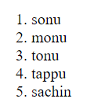

    </ol>

    <ul> **unordered list** in this ordering not mattters

        <li>sonu</li>

        <li>monu</li>

        <li>golmaal</li>

        <li>rr</li>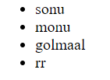

    </ul>

</body>

</html>

What are attributes:

Attributes are the extra information which we provide to our browser about that particular/specific element.

Attributes are only provided in the open tag.

<ul type="square">

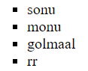 in this we change shape of bullets with attributes.

  <ol type="i" start="-3" reversed>

In this we can change the type of number or order .

If we put negative then till 0 negative no is ordered but then from 1 according to type.

Reversed is a Boolean attribute

If it is present then it will true and it wil reverse the number but order is same.

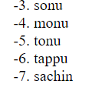

Media element:

<img src="" alt="">

Src is source and alt is for alternative.

. means upar jana and ./ us level ka access

<img src="./assets/1678332167866-removebg-preview.jpg"width="40" alt="">

We have to also set width of image.

…/ is wrong we use for third level ../../